Dear Senator:

On behalf of the American Federation of Government Employees, AFL-CIO (AFGE), which represents more than 800,000 federal and D.C. workers, I write to strongly endorse both the “True Shutdown Fairness Act” introduced by Senator Chris Van Hollen and the "Military and Federal Employee Protection Act’’ introduced by Senator Gary Peters that would enable and mandate federal agencies to pay military personnel and federal civilian employees during the lapse in government funding that began at the start of Fiscal Year 2026.

Whether they are declared excepted workers or are furloughed, civil servants are generally not paid for the duration of a funding lapse. Yet their obligations to pay mortgages and monthly rents, credit card bills and automobile loans, and college tuition and charitable pledges remain. Every missed pay period deepens the financial hole in which our members and their families find themselves. By the time Congress finally reaches a compromise, the damage has been done – to their bank accounts, to their credit ratings, and all too often, to their health and dignity.

The bills offered by Sen. Van Hollen and Sen. Peters would guarantee that civil servants and military personnel who have not been paid since October 1 are made whole. These measures recognize that federal workers were not given the choice between taking excepted or furloughed status when shutdown began three weeks ago and should not suffer direct economic harm because of Congress’s inability to agree on the federal government’s spending and policy priorities in FY26.
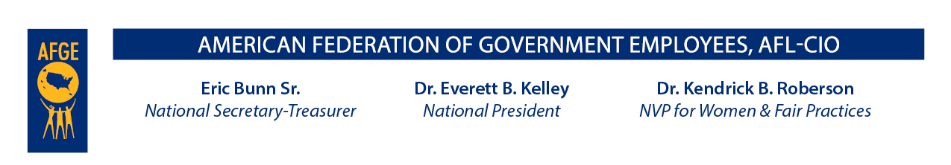

October
2
3
, 2025

Unlike Sen. Johnson’s errantly titled “Shutdown Fairness Act” that was introduced last week, the Van Hollen and Peters measures truly are fair insofar as they recognize that all federal workers and military personnel, regardless of their position in the federal government, their wage or salary level, or the agency for which they work, are entitled to paychecks they have not received since October 1.

To be clear, these bills are no substitute for a return to an orderly and predictable appropriations process that would fund the operations of the federal government in time for the start of a new fiscal year. However, in the absence of a bipartisan compromise that would end the spending impasse, AFGE urges you to support the “True
Shutdown Fairness Act” introduced by Senator Chris Van Hollen and the "Military and Federal Employee Protection Act’’ introduced by Senator Gary Peters to blunt the financial harm that federal workers are experiencing.

Sincerely,
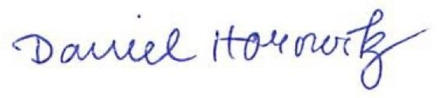
Daniel Horowitz
Legislative Director

